Renewed Furniture Hub

Design Document

**Version 1.0**

**Group Id: S25PROJECTC2242**

**Supervisor Name: Syed Hassan Ali Shah**

**Revision History**

|  |  |  |  |
| --- | --- | --- | --- |
| **Date (dd/mm/yyyy)** | **Version** | **Description** | **Author** |
| 20/07/2025 | 1.0 | This design document provides detailed descriptions and diagrams, including ERD, sequence diagrams, architecture design, class diagrams, database design, interface design, and test cases, to serve as a comprehensive blueprint for developing the renewed furniture hub. | BC230407113 |
|  |  |  |  |
|  |  |  |  |
|  |  |  |  |

**Table of Content**

TASK#1 10

Introduction of Design Document:- 10

TASK#2 15

Entity Relationship Diagram (ERD) 15

TASK#3 16

Sequence Diagrams:- 16

**1)** **Register as New User** 16

16

**2)** **Login (for Guest, RegisteredUser, Admin)** 16

17

**3)** **Search Furniture (for Guest, RegisteredUser)** 17

18

**4)** **View Furniture Details** 18

**5)** **Manage Furniture (Registered User)** 19

20

**7)** **Give Review and Feedback** 22

**13)** **Manage Complaints(Resolve/Delete)** 27

28

**14)** **Manage Complaints(Resolve/Delete)** 28

29

**15)** **Logout** 29

30

TASK#4 30

Architecture Design Diagram:- 31

TASK#5 31

Class Diagram:- 32

TASK#6 33

**Database Design** 33

TASK#7 34

Interface Designs- 34

**HomePage:-** 34

**Register Page:-** 35

**Login Pages:-** 36

**Customer Dashboard:-** 37

TASK#8 :- 37

Test Cases 37

01. Register as New User 37

02. Login (for Guest, RegisteredUser, Admin) 38

03. Search Furniture (Multiple actors) 38

04. View Furniture Details 38

05. Upload Furniture (Registered User) 39

06. Update/Delete Uploaded Furniture (Registered User) 39

07. Update User Profile 39

08. Give Review and Feedback 40

09. Submit Complaint 40

10. Give Rating 40

11. Buy Furniture (with Payment) 40

12. Admin Login 41

13. Manage Furniture (Admin) 41

14. View Admin Dashboard 41

15. Manage Users (Accept/Reject/Block) 42

16. Generate Reports (Sales Summary) 42

17. Logout (for Guest, RegisteredUser, Admin) 42

# TASK#1

## **Introduction of Design Document**:-

This design document outlines the detailed design and architecture of the Online Community Online the renewed furniture hub. It includes essential diagrams and descriptions that provide a comprehensive understanding of the system's structure and behavior. The primary purpose of this document is to serve as a blueprint for the development team, ensuring that all aspects of the system are well-documented and clearly defined.

1. **Entity Relationship Diagram (ERD)**

* **Entities**: Represent objects or concepts, such as that have data stored about them.
* **Relationships:** Illustrate how entities are connected
* **Attributes:**  Characteristics or properties of entities, such as User_ID for Users.
* This diagram provides a visual representation of the data model, illustrating the relationships between different entities within the system. This diagram is crucial for understanding how data is structured and interconnected.

1. **Sequence Diagrams:**

* **Objects:** Instances of classes that interact in the system.
* **Messages:** Communications between objects, shown as arrows.
* **Lifelines:** Represent the existence of an object over time.
* **Activation:** Represented by a thin rectangle or a tall, thin box, this shows when a participant is actively performing an action or operation.
* **Deactivation:** Represented by a small circle or a short, thin rectangle, this shows when a participant's action or operation is complete.
* **Conditions:** Represented by a diamond or a rectangle with a decision icon, these show the conditions or logic that govern the interactions.
* **Alternative paths:** Represented by a diamond or a rectangle with multiple outgoing arrows, these show alternative scenarios or branches.

Sequence diagrams are provided for each use case, detailing the interactions between objects over time. These diagrams help in visualizing the flow of tasks within the system and are essential for understanding the dynamic behavior of the system.

1. **Architecture Design Diagram:**

* **Layers:** Different levels of the system, such as presentation, business logic, and data access layers.
* **Components:** Functional units within each layer, like User Interface, and Database.
* **Interactions:** How layers and components communicate with each other.

The architecture design diagram presents a tiered architecture of the system, highlighting the different layers and their interactions. This section is important for understanding the overall structure and deployment of the system.

1. **Class Diagram:**

* **Classes:** Blueprints for objects, defining attributes and methods, like User, Admin.
* **Relationships:** Connections between classes, such as inheritance (Admin inherits from User), association, aggregation, and composition.
* **Attributes and Methods:** Characteristics and behaviors defined within each class. The class diagram provides a static view of the system, showing the system classes, their attributes, methods, and relationships. This diagram is fundamental for object-oriented design and development.
* **Inheritance:** Represented by an arrow pointing from a subclass to a super class, this shows the inheritance relationship between classes.
* **Composition:** Represented by a filled diamond at the end of a line connecting classes, this shows the whole-part relationship between classes.
* **Association:** Represented by a line connecting classes, this shows the relationship between classes, such as a student enrolling in a course.
* **Multiplicity:** Represented by numbers or symbols at the ends of a line connecting classes, this shows the cardinality of the relationship, such as one-to-one or many-to-many.
* **Dependencies:** Represented by a dashed arrow pointing from a dependent class to an independent class, this shows the dependency relationship between classes.
* **Interfaces:** Represented by a circle or a rectangle with a name, these define a contract or a set of operations that a class must implement.

1. %3CmxGraphModel%3E%3Croot%3E%3CmxCell%20id%3D%220%22%2F%3E%3CmxCell%20id%3D%221%22%20parent%3D%220%22%2F%3E%3CUserObject%20label%3D%22%22%20tags%3D%22Background%22%20id%3D%222%22%3E%3CmxCell%20style%3D%22vsdxID%3D1%3BfillColor%3Dnone%3BgradientColor%3Dnone%3BstrokeColor%3Dnone%3Bpoints%3D%5B%5B1%2C0.5%2C0%5D%2C%5B0.5%2C0.5%2C0%5D%2C%5B0.5%2C0%2C0%5D%5D%3BlabelBackgroundColor%3Dnone%3Brounded%3D0%3Bhtml%3D1%3BwhiteSpace%3Dwrap%3B%22%20vertex%3D%221%22%20parent%3D%221%22%3E%3CmxGeometry%20x%3D%22838%22%20y%3D%2234%22%20width%3D%22254%22%20height%3D%22401%22%20as%3D%22geometry%22%2F%3E%3C%2FmxCell%3E%3C%2FUserObject%3E%3CmxCell%20id%3D%223%22%20style%3D%22vsdxID%3D2%3BfillColor%3D%23ffffff%3BgradientColor%3Dnone%3Bshape%3Dstencil(rZBLDoAgDERP0z3SI%2Fi5B4kojQgE8Xd7IY3RuHY303lt0gGsF6OCBimWFP2kd%2BqTAWxASnJGR0pZAbaA9eCjHqNfXc8%2BqEIWNfutXDh4T5QNKU52lWDfMWrJvdA7%2FB%2F%2BC83i%2BXMga7mmd%2F7tJY%2B4U2wv)%3BstrokeColor%3D%23ffffff%3Bpoints%3D%5B%5B0%2C0.5%2C0%5D%2C%5B1%2C0.5%2C0%5D%2C%5B0.5%2C1%2C0%5D%2C%5B0.5%2C0%2C0%5D%5D%3BlabelBackgroundColor%3Dnone%3Brounded%3D0%3Bhtml%3D1%3BwhiteSpace%3Dwrap%3B%22%20vertex%3D%221%22%20parent%3D%222%22%3E%3CmxGeometry%20width%3D%22254%22%20height%3D%221%22%20as%3D%22geometry%22%2F%3E%3C%2FmxCell%3E%3CmxCell%20id%3D%224%22%20style%3D%22vsdxID%3D3%3BfillColor%3D%23d8d8d8%3BgradientColor%3Dnone%3Bshape%3Dstencil(nZBLDoAgDERP0z3SIyjew0SURgSD%2BLu9kMZoXLhwN9O%2BtukAlrNpJg1SzDH4QW%2FURgNYgZTkjA4UkwJUgGXng%2B6DX1zLfmoymdXo17xh5zmRJ6Q42BWCfc2oJfdAr%2BYv%2BAP9Cb7OJ3H%2F2JG1HNGz%2F84klThPVCc%3D)%3BstrokeColor%3D%23ffffff%3Bpoints%3D%5B%5B0%2C0.5%2C0%5D%2C%5B1%2C0.5%2C0%5D%2C%5B0.5%2C1%2C0%5D%2C%5B0.5%2C0%2C0%5D%5D%3BlabelBackgroundColor%3Dnone%3Brounded%3D0%3Bhtml%3D1%3BwhiteSpace%3Dwrap%3B%22%20vertex%3D%221%22%20parent%3D%222%22%3E%3CmxGeometry%20width%3D%22254%22%20height%3D%22401%22%20as%3D%22geometry%22%2F%3E%3C%2FmxCell%3E%3CmxCell%20id%3D%225%22%20value%3D%22%22%20style%3D%22vsdxID%3D4%3BedgeStyle%3Dnone%3Bdashed%3D1%3BdashPattern%3D2.00%202.00%3BstartArrow%3Dnone%3BendArrow%3Dnone%3BstartSize%3D5%3BendSize%3D5%3BstrokeColor%3D%23115582%3BspacingTop%3D0%3BspacingBottom%3D0%3BspacingLeft%3D0%3BspacingRight%3D0%3BverticalAlign%3Dmiddle%3Bhtml%3D1%3BlabelBackgroundC

%22600%22%20as%3D%22sourcePoint%22%2F%3E%3CmxPoint%20x%3D%22740%22%20y%3D%22550%22%20as%3D%22targetPoint%22%2F%3E%3C%2FmxGeometry%3E%3C%2FmxCell%3E%3CmxCell%20id%3D%22176%22%20value%3D%22%22%20style%3D%22endArrow%3Dnone%3Bhtml%3D1%3Brounded%3D0%3BexitX%3D0.063%3BexitY%3D0.994%3BexitDx%3D0%3BexitDy%3D0%3BexitPerimeter%3D0%3B%22%20edge%3D%221%22%20source%3D%2215%22%20parent%3D%221%22%3E%3CmxGeometry%20width%3D%2250%22%20height%3D%2250%22%20relative%3D%221%22%20as%3D%22geometry%22%3E%3CmxPoint%20x%3D%22650%22%20y%3D%22600%22%20as%3D%22sourcePoint%22%2F%3E%3CmxPoint%20x%3D%221537%22%20y%3D%22547%22%20as%3D%22targetPoint%22%2F%3E%3C%2FmxGeometry%3E%3C%2FmxCell%3E%3CmxCell%20id%3D%22177%22%20value%3D%22%22%20style%3D%22endArrow%3Dnone%3Bhtml%3D1%3Brounded%3D0%3B%22%20edge%3D%221%22%20parent%3D%221%22%3E%3CmxGeometry%20width%3D%2250%22%20height%3D%2250%22%20relative%3D%221%22%20as%3D%22geometry%22%3E%3CmxPoint%20x%3D%221491%22%20y%3D%22140%22%20as%3D%22sourcePoint%22%2F%3E%3CmxPoint%20x%3D%221716%22%20y%3D%22140%22%20as%3D%22targetPoint%22%2F%3E%3C%2FmxGeometry%3E%3C%2FmxCell%3E%3CmxCell%20id%3D%22178%22%20value%3D%22%22%20style%3D%22endArrow%3Dnone%3Bhtml%3D1%3Brounded%3D0%3BexitX%3D0.97%3BexitY%3D0.138%3BexitDx%3D0%3BexitDy%3D0%3BexitPerimeter%3D0%3B%22%20edge%3D%221%22%20source%3D%22143%22%20parent%3D%221%22%3E%3CmxGeometry%20width%3D%2250%22%20height%3D%2250%22%20relative%3D%221%22%20as%3D%22geometry%22%3E%3CmxPoint%20x%3D%221590%22%20y%3D%22640%22%20as%3D%22sourcePoint%22%2F%3E%3CmxPoint%20x%3D%221650%22%20y%3D%22640%22%20as%3D%22targetPoint%22%2F%3E%3C%2FmxGeometry%3E%3C%2FmxCell%3E%3CmxCell%20id%3D%22179%22%20value%3D%22%22%20style%3D%22endArrow%3Dnone%3Bhtml%3D1%3Brounded%3D0%3BentryX%3D0.597%3BentryY%3D1.023%3BentryDx%3D0%3BentryDy%3D0%3BentryPerimeter%3D0%3B%22%20edge%3D%221%22%20source%3D%2228%22%20target%3D%22133%22%20parent%3D%221%22%3E%3CmxGeometry%20width%3D%2250%22%20height%3D%2250%22%20relative%3D%221%22%20as%3D%22geometry%22%3E%3CmxPoint%20x%3D%22900%22%20y%3D%22480%22%20as%3D%22sourcePoint%22%2F%3E%3CmxPoint%20x%3D%22950%22%20y%3D%22430%22%20as%3D%22targetPoint%22%2F%3E%3C%2FmxGeometry%3E%3C%2FmxCell%3E%3CmxCell%20id%3D%22180%22%20value%3D%22%22%20style%3D%22endArrow%3Dnone%3Bhtml%3D1%3Brounded%3D0%3BentryX%3D0.106%3BentryY%3D0.991%3BentryDx%3D0%3BentryDy%3D0%3BentryPerimeter%3D0%3B%22%20edge%3D%221%22%20target%3D%228%22%20parent%3D%221%22%3E%3CmxGeometry%20width%3D%2250%22%20height%3D%2250%22%20relative%3D%221%22%20as%3D%22geometry%22%3E%3CmxPoint%20x%3D%221030%22%20y%3D%221110%22%20as%3D%22sourcePoint%22%2F%3E%3CmxPoint%20x%3D%221080%22%20y%3D%221060%22%20as%3D%22targetPoint%22%2F%3E%3C%2FmxGeometry%3E%3C%2FmxCell%3E%3CmxCell%20id%3D%22181%22%20value%3D%22%22%20style%3D%22endArrow%3Dnone%3Bhtml%3D1%3Brounded%3D0%3BexitX%3D0.5%3BexitY%3D0%3BexitDx%3D0%3BexitDy%3D0%3BexitPerimeter%3D0%3B%22%20edge%3D%221%22%20source%3D%2247%22%20parent%3D%221%22%3E%3CmxGeometry%20width%3D%2250%22%20height%3D%2250%22%20relative%3D%221%22%20as%3D%22geometry%22%3E%3CmxPoint%20x%3D%221839%22%20y%3D%221134%22%20as%3D%22sourcePoint%22%2F%3E%3CmxPoint%20x%3D%221825.69%22%20y%3D%22839%22%20as%3D%22targetPoint%22%2F%3E%3C%2FmxGeometry%3E%3C%2FmxCell%3E%3CmxCell%20id%3D%22182%22%20value%3D%22%22%20style%3D%22endArrow%3Dnone%3Bhtml%3D1%3Brounded%3D0%3BentryX%3D0.991%3BentryY%3D0.865%3BentryDx%3D0%3BentryDy%3D0%3BentryPerimeter%3D0%3B%22%20edge%3D%221%22%20target%3D%2233%22%20parent%3D%221%22%3E%3CmxGeometry%20width%3D%2250%22%20height%3D%2250%22%20relative%3D%221%22%20as%3D%22geometry%22%3E%3CmxPoint%20x%3D%221715%22%20y%3D%221136%22%20as%3D%22sourcePoint%22%2F%3E%3CmxPoint%20x%3D%221720%22%20y%3D%221060%22%20as%3D%22targetPoint%22%2F%3E%3C%2FmxGeometry%3E%3C%2FmxCell%3E%3CmxCell%20id%3D%22183%22%20value%3D%22%22%20style%3D%22endArrow%3Dnone%3Bhtml%3D1%3Brounded%3D0%3BentryX%3D0.022%3BentryY%3D0.958%3BentryDx%3D0%3BentryDy%3D0%3BentryPerimeter%3D0%3BexitX%3D0.007%3BexitY%3D0.205%3BexitDx%3D0%3BexitDy%3D0%3BexitPerimeter%3D0%3B%22%20edge%3D%221%22%20source%3D%2242%22%20target%3D%22133%22%20parent%3D%221%22%3E%3CmxGeometry%20width%3D%2250%22%20height%3D%2250%22%20relative%3D%221%22%20as%3D%22geometry%22%3E%3CmxPoint%20x%3D%22883%22%20y%3D%221098%22%20as%3D%22sourcePoint%22%2F%3E%3CmxPoint%20x%3D%22720%22%20y%3D%22630%22%20as%3D%22targetPoint%22%2F%3E%3C%2FmxGeometry%3E%3C%2FmxCell%3E%3CmxCell%20id%3D%22184%22%20value%3D%22%22%20style%3D%22endArrow%3Dnone%3Bhtml%3D1%3Brounded%3D0%3BentryX%3D0.28%3BentryY%3D0.987%3BentryDx%3D0%3BentryDy%3D0%3BentryPerimeter%3D0%3B%22%20edge%3D%221%22%20source%3D%2233%22%20parent%3D%221%22%3E%3CmxGeometry%20width%3D%2250%22%20height%3D%2250%22%20relative%3D%221%22%20as%3D%22geometry%22%3E%3CmxPoint%20x%3D%221378%22%20y%3D%221100%22%20as%3D%22sourcePoint%22%2F%3E%3CmxPoint%20x%3D%221651%22%20y%3D%22749%22%20as%3D%22targetPoint%22%2F%3E%3C%2FmxGeometry%3E%3C%2FmxCell%3E%3CmxCell%20id%3D%22185%22%20value%3D%22%22%20style%3D%22endArrow%3Dnone%3Bhtml%3D1%3Brounded%3D0%3BexitX%3D0.97%3BexitY%3D-0.009%3BexitDx%3D0%3BexitDy%3D0%3BexitPerimeter%3D0%3BentryX%3D0.01%3BentryY%3D-0.008%3BentryDx%3D0%3BentryDy%3D0%3BentryPerimeter%3D0%3B%22%20edge%3D%221%22%20source%3D%2238%22%20target%3D%22153%22%20parent%3D%221%22%3E%3CmxGeometry%20width%3D%2250%22%20height%3D%2250%22%20relative%3D%221%22%20as%3D%22geometry%22%3E%3CmxPoint%20x%3D%22596%22%20y%3D%22968%22%20as%3D%22sourcePoint%22%2F%3E%3CmxPoint%20x%3D%221262%22%20y%3D%22850%22%20as%3D%22targetPoint%22%2F%3E%3C%2FmxGeometry%3E%3C%2FmxCell%3E%3CmxCell%20id%3D%22186%22%20value%3D%22%22%20style%3D%22endArrow%3Dnone%3Bhtml%3D1%3Brounded%3D0%3BentryX%3D0.014%3BentryY%3D0.819%3BentryDx%3D0%3BentryDy%3D0%3BentryPerimeter%3D0%3B%22%20edge%3D%221%22%20target%3D%22101%22%20parent%3D%221%22%3E%3CmxGeometry%20width%3D%2250%22%20height%3D%2250%22%20relative%3D%221%22%20as%3D%22geometry%22%3E%3CmxPoint%20x%3D%221134%22%20y%3D%22683%22%20as%3D%22sourcePoint%22%2F%3E%3CmxPoint%20x%3D%221262%22%20y%3D%22683%22%20as%3D%22targetPoint%22%2F%3E%3C%2FmxGeometry%3E%3C%2FmxCell%3E

1. **Database Design:**

* **Tables:** Structures that store data, corresponding to entities in the ERD.
* **Columns:** Fields within tables, representing attributes.
* **Relationships:** Connections between tables, implemented via foreign keys. The database design section includes diagrams that detail the schema of the database, ensuring that the data is organized efficiently and supports the application's requirements.

1. **Interface Design:**

* **Screenshots:** Visual representations of the user interface.
* **Layouts:** Arrangement of elements on the screen.
* **User Interactions:** How users interact with the interface.
* **Accessibility:** A description of the accessibility features and considerations, including WCAG guidelines and screen reader support.
* **Responsive Design:** A description of the responsive design approach, including breakpoints, layouts, and media queries.
* **Design Rationale:** A explanation of the design decisions, including the reasoning behind the design choices.

This section provides screenshots of the system's graphical user interface (GUI). It show cases the main interfaces, demonstrating the application's most important features and how users will interact with the system.

**8. Test Cases:**

* **Test Scenarios:** Specific situations to be tested.
* **Test Steps:** Detailed actions to perform the test.
* **Expected Results:** Anticipated outcomes of the test.

Test cases for each use case scenario are provided to ensure that the system's functionality is thoroughly tested. This section is vital for validating the system against its requirements and ensuring its reliability.

**Benefits and Purpose of the Design Phase:**

The design phase in a software development project is critical for several reasons:

* **Clarity and Communication:** It provides a clear and shared understanding of the system among all stakeholders, including developers, designers, and clients.
* **Blueprint for Development:** It serves as a detailed blueprint that guides the development process, ensuring that all components are developed in a coherent and consistent manner.
* **Risk Mitigation:** By defining the system architecture and design early potential issues can be identified and addressed before implementation begins, reducing risks and avoiding costly changes later.
* **Quality Assurance:** Detailed design documentation supports rigorous testing and validation, helping to ensure that the final product meets the specified requirements and standards.
* **Scalability and Maintenance:** A well-thought-out design facilitates future scalability and ease of maintenance, allowing the system to evolve with changing requirements.

This document is instrumental in ensuring the successful development and deployment of the renewed furniture hub, providing a solid foundation for building a robust, efficient, and user-friendly application.

# TASK#2

## **Entity Relationship Diagram (ERD)**

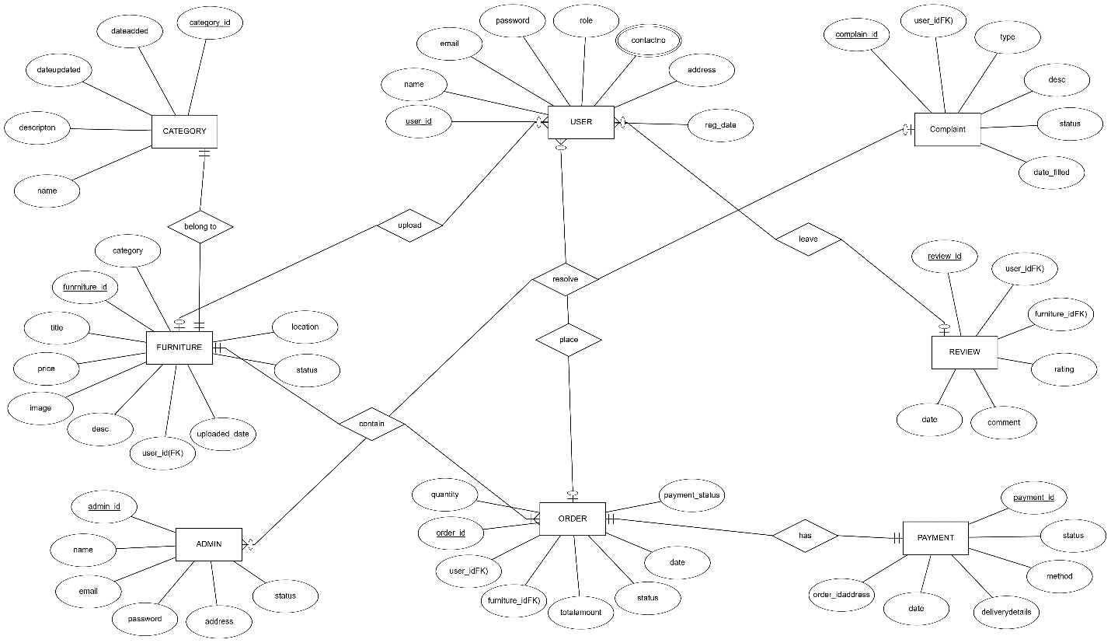

**Diagram 1**

# TASK#3

## **Sequence Diagrams****:-**

1. **Register as New User**

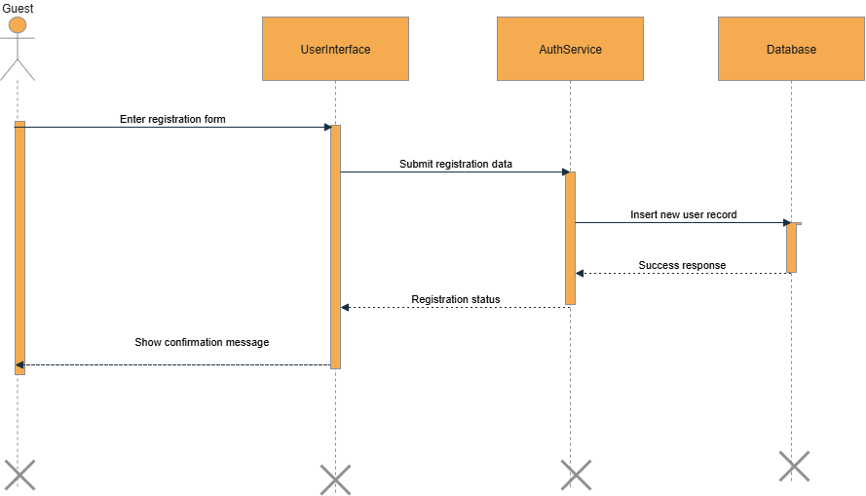

**Diagram 2**

1. **Login (for Guest, RegisteredUser, Admin)**

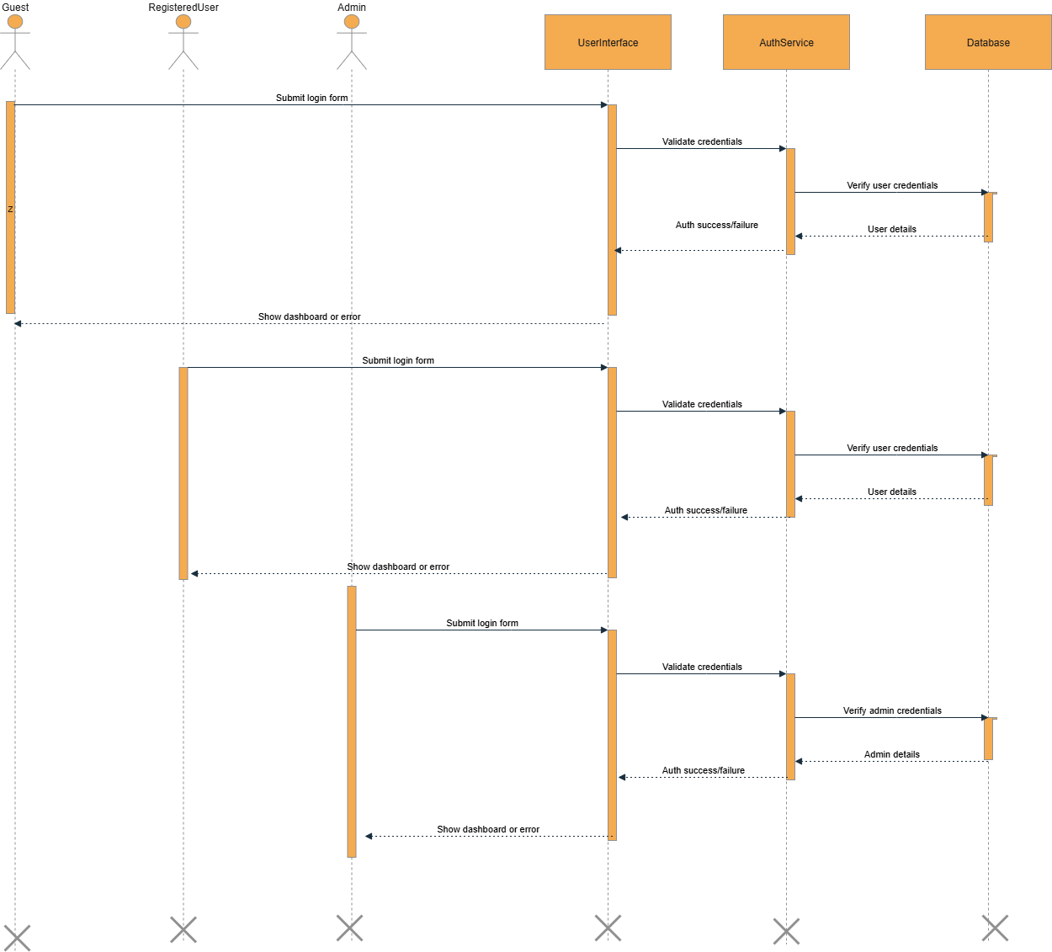

**Diagram 3**

1. **Search Furniture (for Guest, RegisteredUser)**

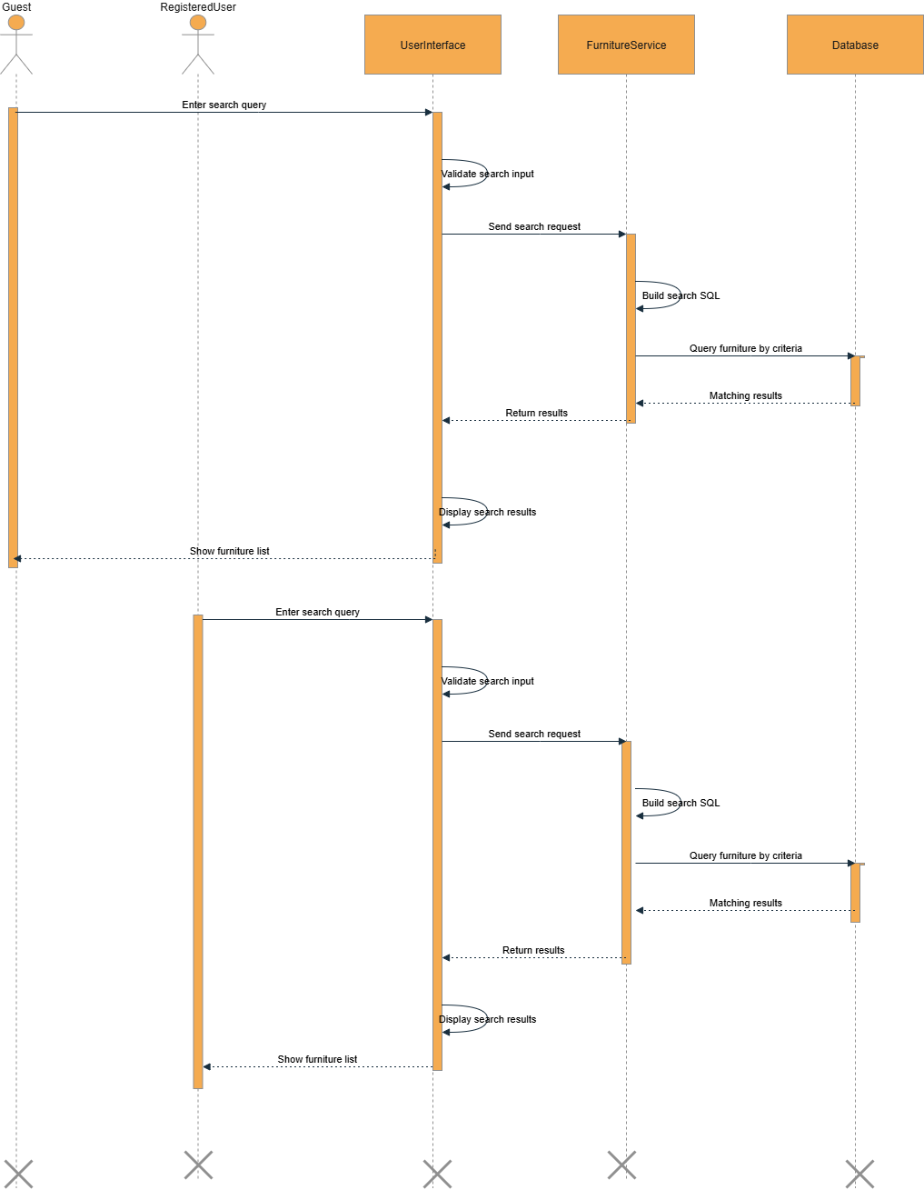

**Diagram 4**

1. **View Furniture Details**

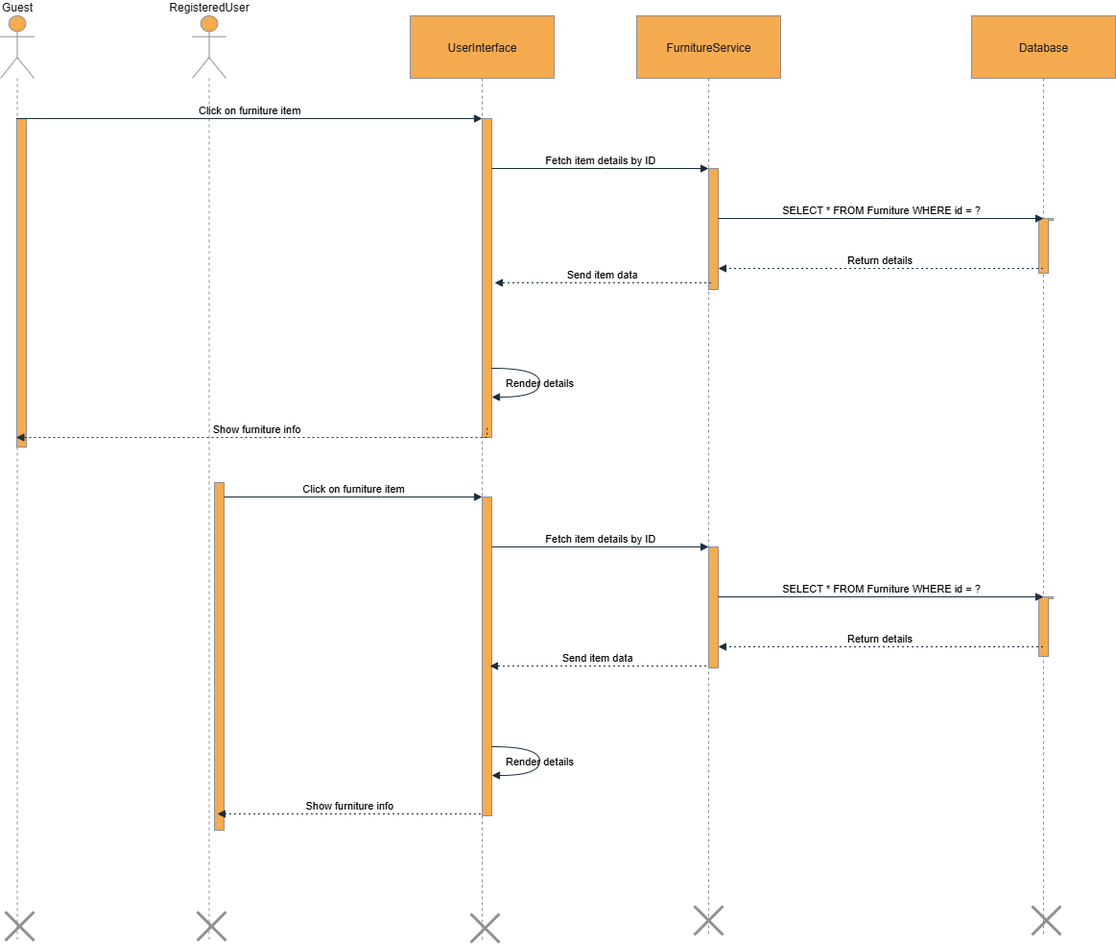

**Diagram 5**

1. **Manage Furniture (Registered User)**

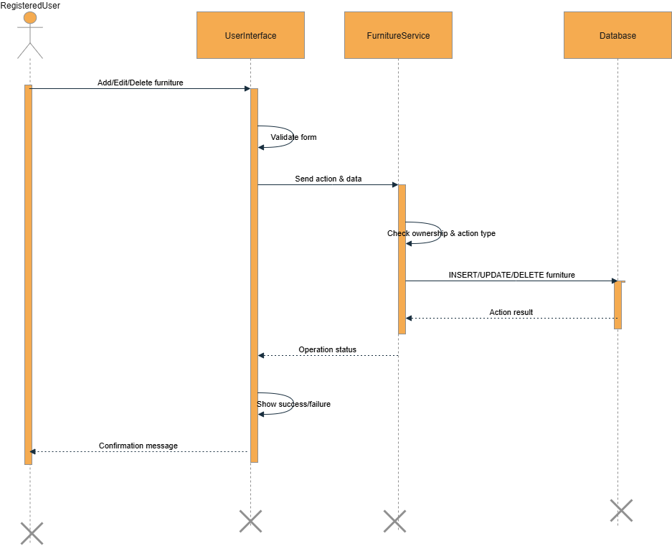

**Diagram 6**

1. **Manage UserProfile**

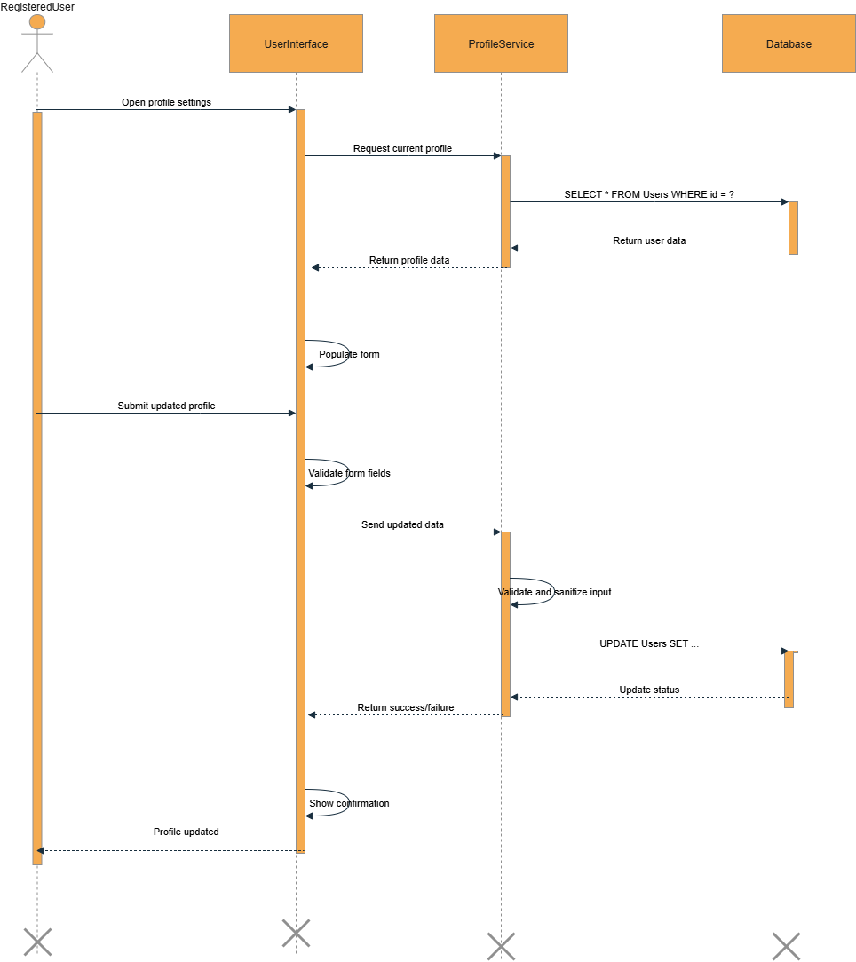

**Diagram 7**

1. **Give Review and Feedback**

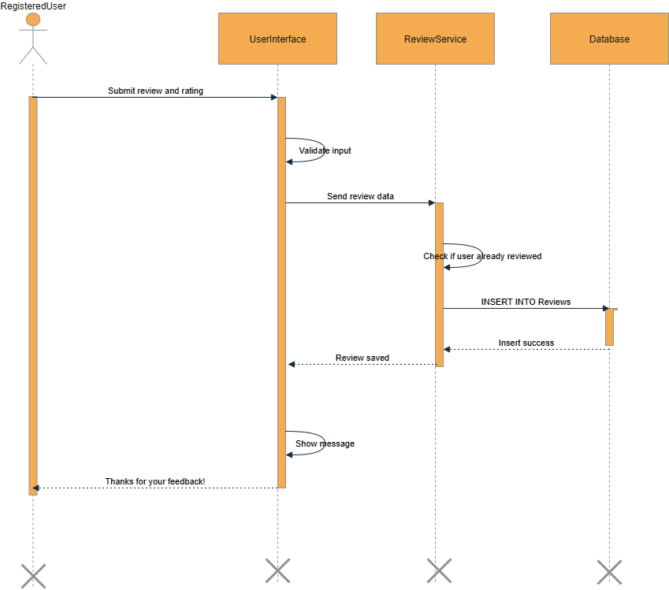

**Diagram 8**

1. **Submit Complaints**

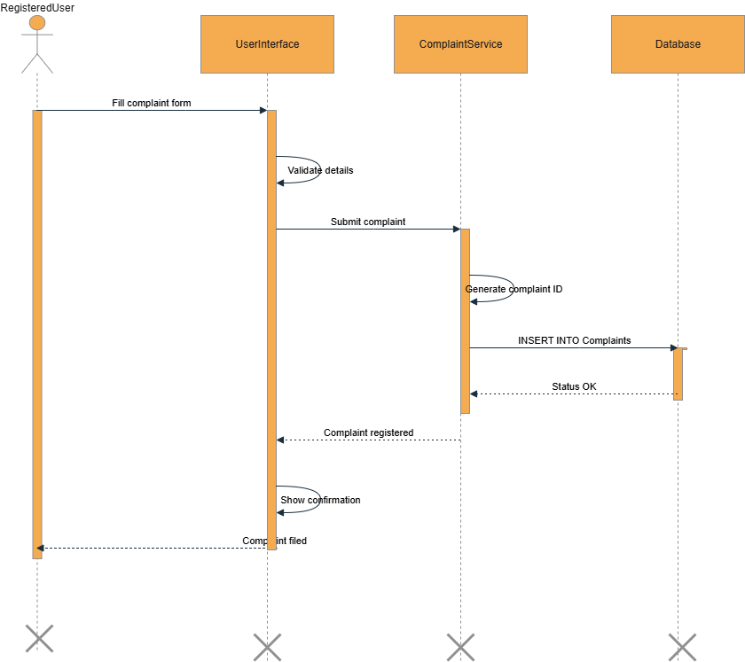

**Diagram 9**

1. **Buy Furniture**

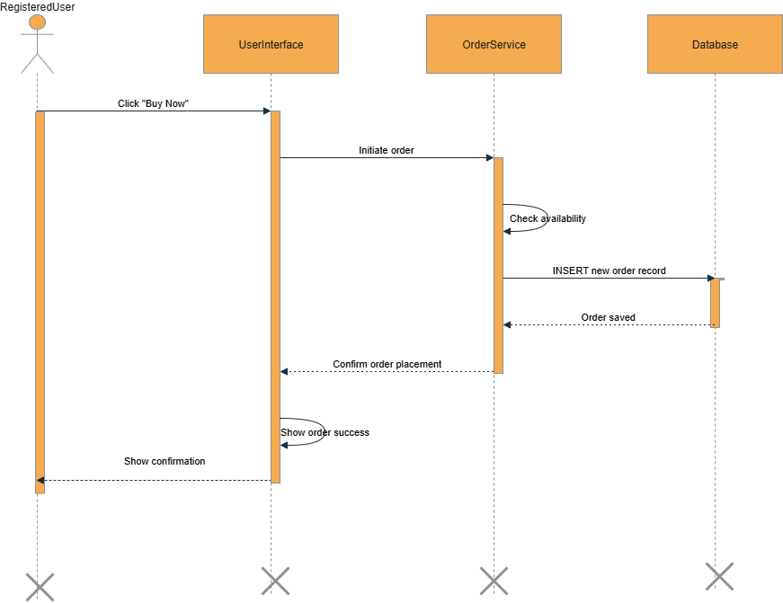

**Diagram 10**

1. **Make Payment**

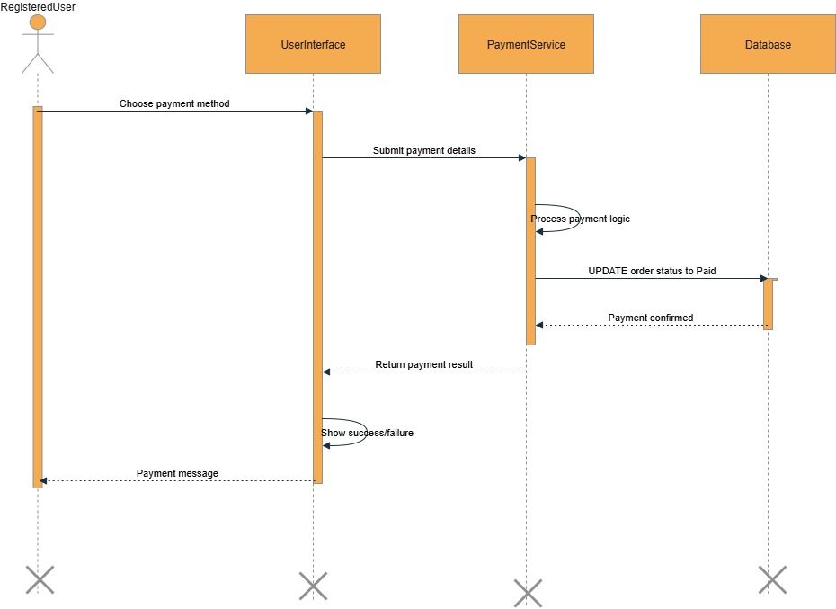

**Diagram 11**

1. **View Admin Dashboard**

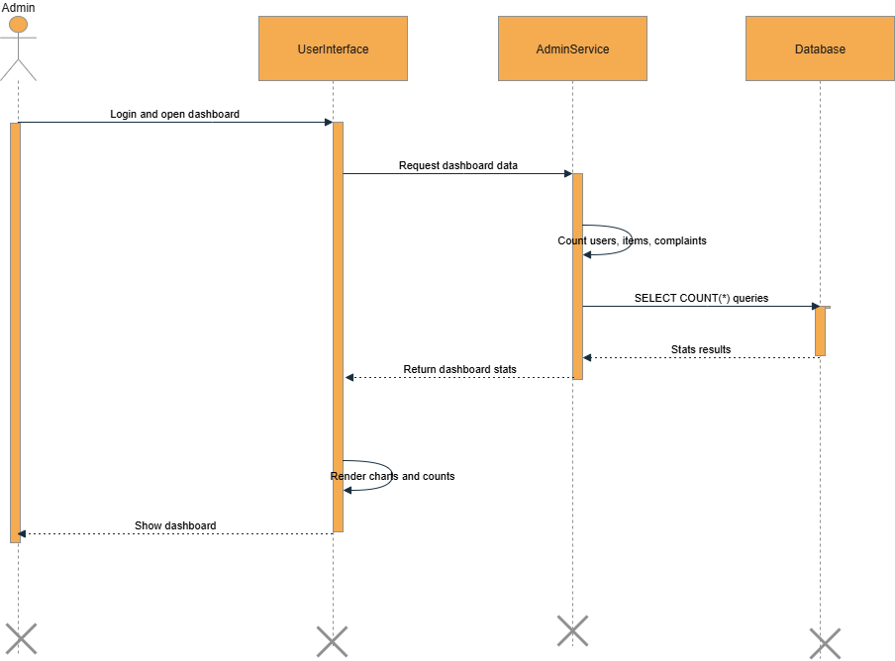

**Diagram 12**

1. **Manage Users (Admin)**

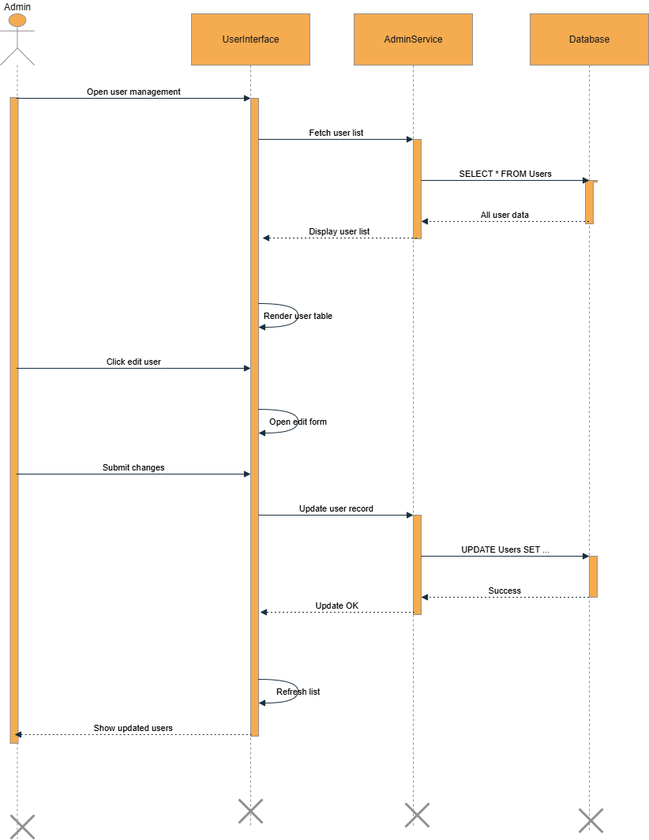

**Diagram 13**

1. **Manage Complaints(Resolve/Delete)**

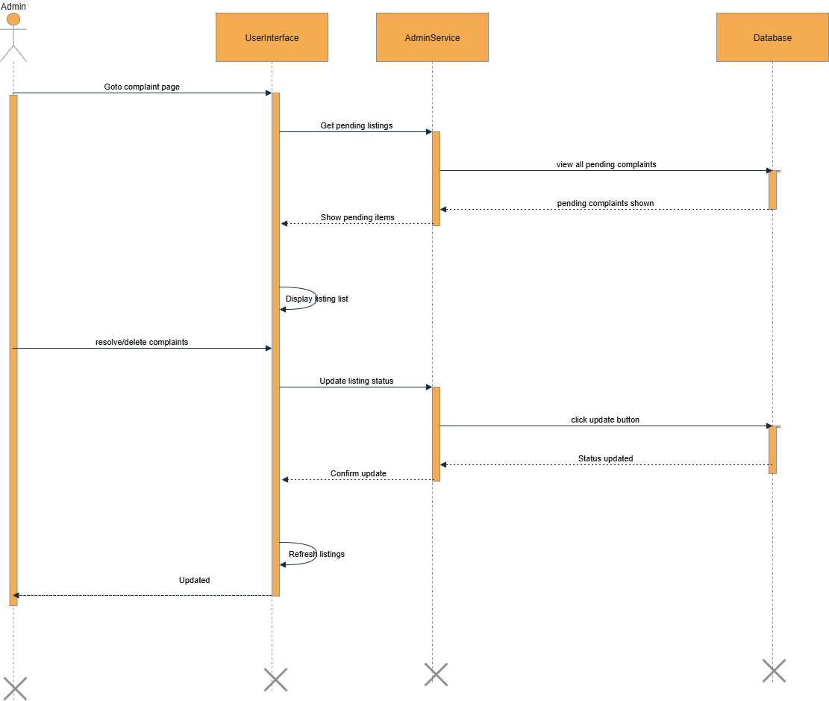

**Diagram 14**

1. **Manage Complaints(Resolve/Delete)**

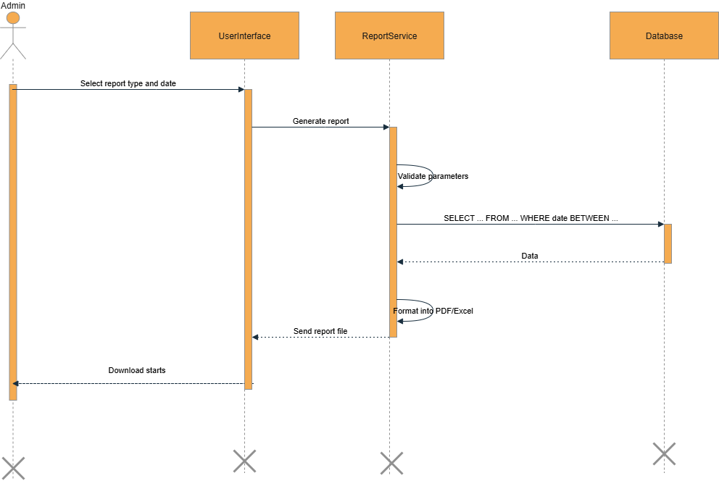

**Diagram 15**

1. **Logout**

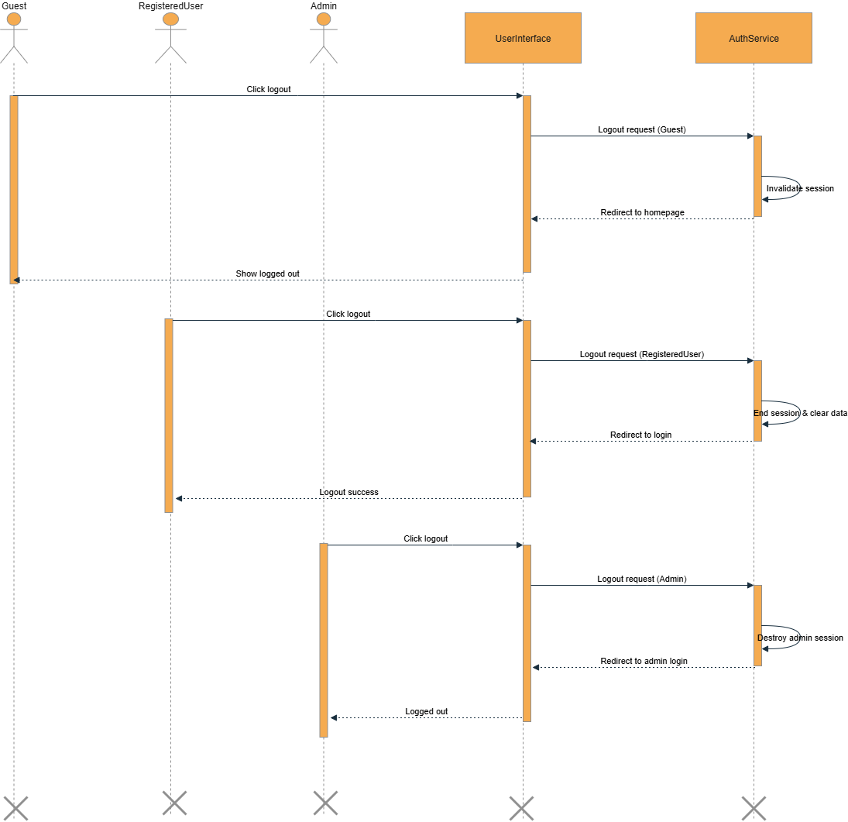

**Diagram 16**

# TASK#4

## **Architecture Design Diagram:-**

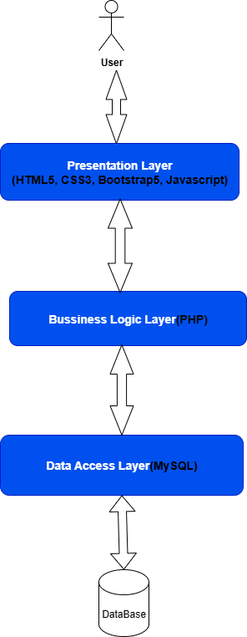

**Diagram 17**

# TASK#5

## **Class Diagram:-**

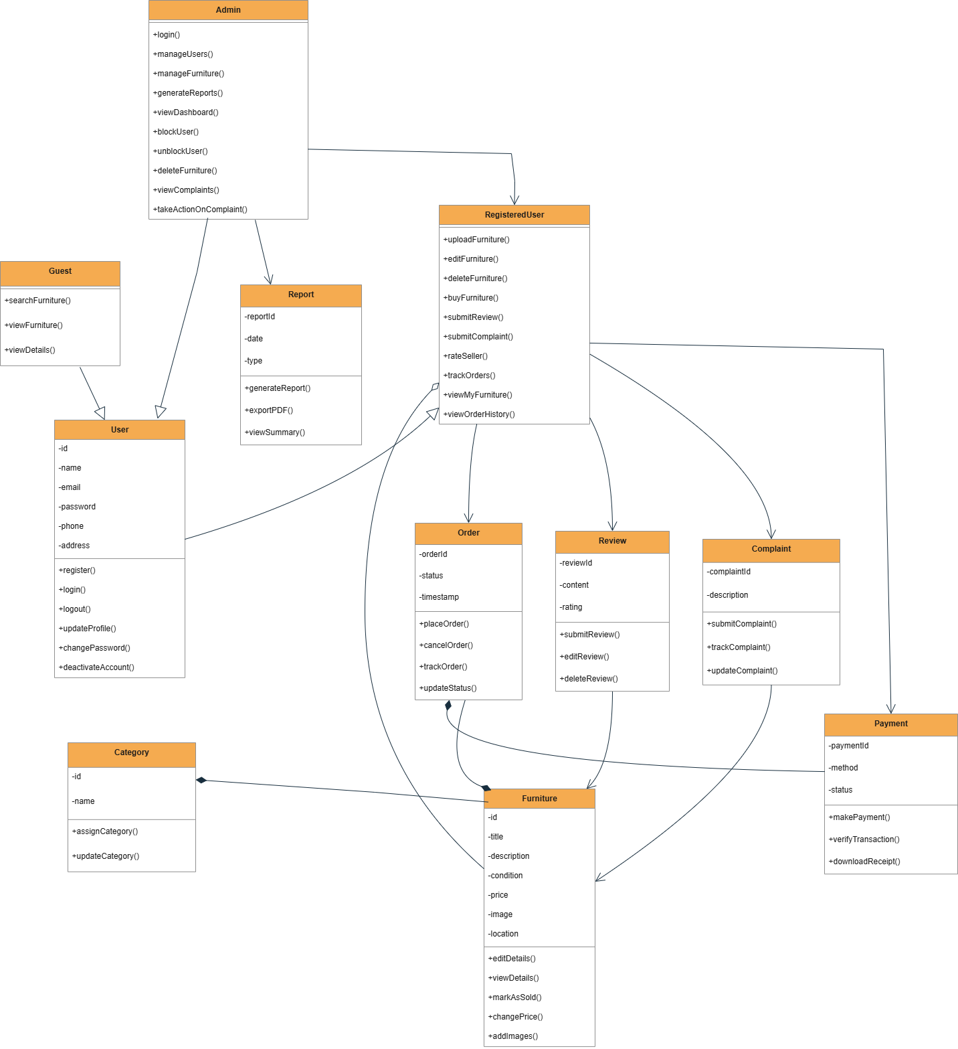

**Diagram 18**

# TASK#6

### **Database Design**

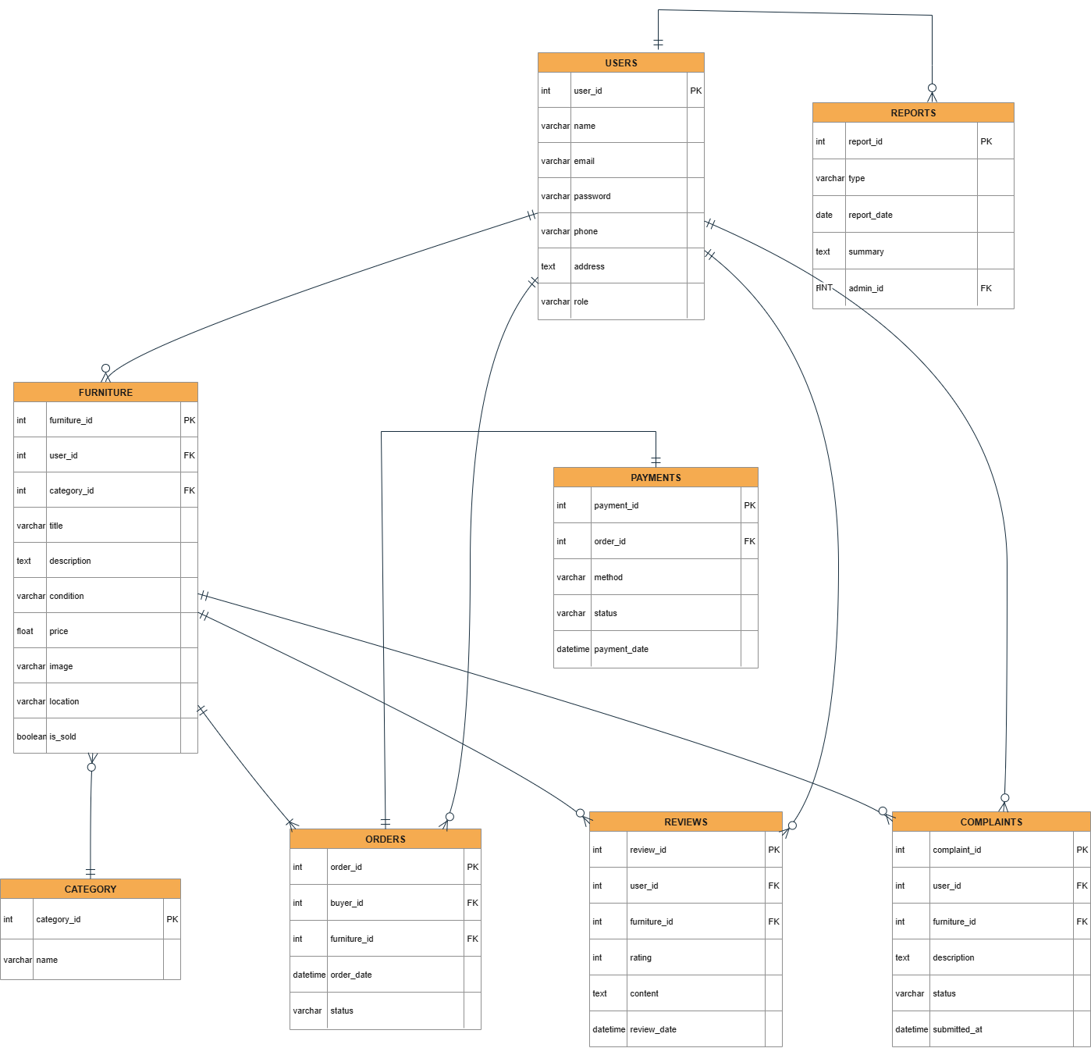

**Diagram 19**

# TASK#7

## **Interface Designs-**

### **HomePage:-**

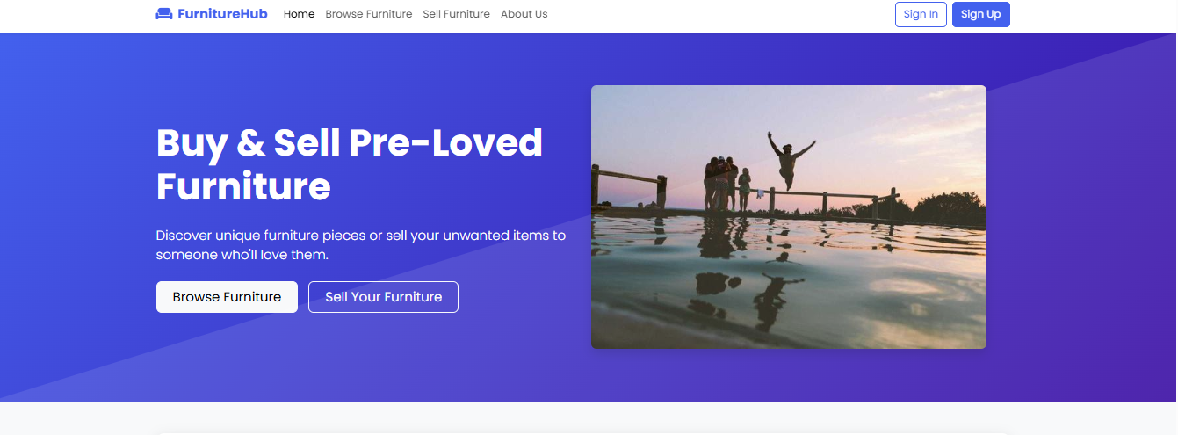

### **Register Page:-**

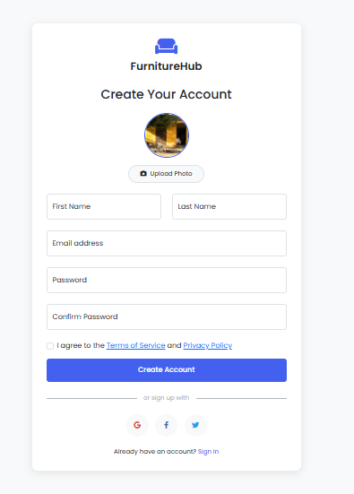

### **Login Pages:-**

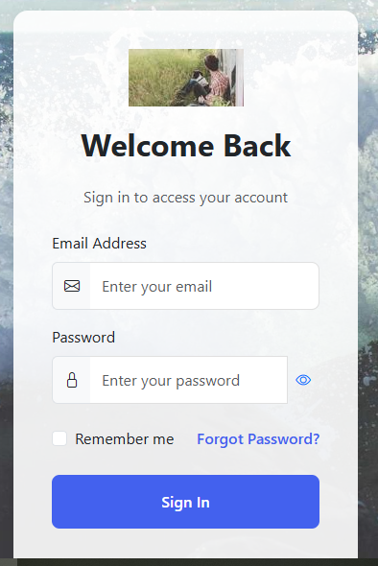

### **Customer Dashboard:-**

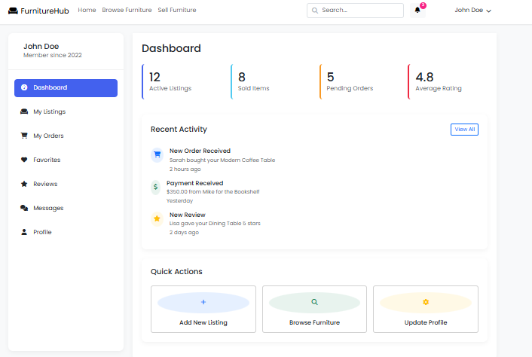

# TASK#8 :-

## **Test Cases**

## 01. Register as New User

|  |  |
| --- | --- |
| Test Case ID | TC_01 |
| Test Case Title | Register as New User |
| Purpose | Verify the function of: register as new user |
| Steps | 1. Launch system 2. Navigate to page 3. Provide necessary input 4. Submit 5. Validate response |
| Input Data | Relevant data based on use case |
| Expected Output | Process completes as intended |
| Final Result | Pass |
| Tested By | BC230407113 |

## 02. Login (for Guest, RegisteredUser, Admin)

|  |  |
| --- | --- |
| Test Case ID | TC_02 |
| Test Case Title | Login (for Guest, RegisteredUser, Admin) |
| Purpose | Verify the function of: login (for guest, registereduser, admin) |
| Steps | 1. Launch system 2. Navigate to page 3. Provide necessary input 4. Submit 5. Validate response |
| Input Data | Relevant data based on use case |
| Expected Output | Process completes as intended |
| Final Result | Pass |
| Tested By | BC230407113 |

## 03. Search Furniture (Multiple actors)

|  |  |
| --- | --- |
| Test Case ID | TC_03 |
| Test Case Title | Search Furniture (Multiple actors) |
| Purpose | Verify the function of: search furniture (multiple actors) |
| Steps | 1. Launch system 2. Navigate to page 3. Provide necessary input 4. Submit 5. Validate response |
| Input Data | Relevant data based on use case |
| Expected Output | Process completes as intended |
| Final Result | Pass |
| Tested By | BC230407113 |

## 04. View Furniture Details

|  |  |
| --- | --- |
| Test Case ID | TC_04 |
| Test Case Title | View Furniture Details |
| Purpose | Verify the function of: view furniture details |
| Steps | 1. Launch system 2. Navigate to page 3. Provide necessary input 4. Submit 5. Validate response |
| Input Data | Relevant data based on use case |
| Expected Output | Process completes as intended |
| Final Result | Pass |
| Tested By | BC230407113 |

## 05. Upload Furniture (Registered User)

|  |  |
| --- | --- |
| Test Case ID | TC_05 |
| Test Case Title | Upload Furniture (Registered User) |
| Purpose | Verify the function of: upload furniture (registered user) |
| Steps | 1. Launch system 2. Navigate to page 3. Provide necessary input 4. Submit 5. Validate response |
| Input Data | Relevant data based on use case |
| Expected Output | Process completes as intended |
| Final Result | Pass |
| Tested By | BC230407113 |

## 06. Update/Delete Uploaded Furniture (Registered User)

|  |  |
| --- | --- |
| Test Case ID | TC_06 |
| Test Case Title | Update/Delete Uploaded Furniture (Registered User) |
| Purpose | Verify the function of: update/delete uploaded furniture (registered user) |
| Steps | 1. Launch system 2. Navigate to page 3. Provide necessary input 4. Submit 5. Validate response |
| Input Data | Relevant data based on use case |
| Expected Output | Process completes as intended |
| Final Result | Pass |
| Tested By | BC230407113 |

## 07. Update User Profile

|  |  |
| --- | --- |
| Test Case ID | TC_07 |
| Test Case Title | Update User Profile |
| Purpose | Verify the function of: update user profile |
| Steps | 1. Launch system 2. Navigate to page 3. Provide necessary input 4. Submit 5. Validate response |
| Input Data | Relevant data based on use case |
| Expected Output | Process completes as intended |
| Final Result | Pass |
| Tested By | BC230407113 |

## 08. Give Review and Feedback

|  |  |
| --- | --- |
| Test Case ID | TC_08 |
| Test Case Title | Give Review and Feedback |
| Purpose | Verify the function of: give review and feedback |
| Steps | 1. Launch system 2. Navigate to page 3. Provide necessary input 4. Submit 5. Validate response |
| Input Data | Relevant data based on use case |
| Expected Output | Process completes as intended |
| Final Result | Pass |
| Tested By | BC230407113 |

## 09. Submit Complaint

|  |  |
| --- | --- |
| Test Case ID | TC_09 |
| Test Case Title | Submit Complaint |
| Purpose | Verify the function of: submit complaint |
| Steps | 1. Launch system 2. Navigate to page 3. Provide necessary input 4. Submit 5. Validate response |
| Input Data | Relevant data based on use case |
| Expected Output | Process completes as intended |
| Final Result | Pass |
| Tested By | BC230407113 |

## 10. Give Rating

|  |  |
| --- | --- |
| Test Case ID | TC_10 |
| Test Case Title | Give Rating |
| Purpose | Verify the function of: give rating |
| Steps | 1. Launch system 2. Navigate to page 3. Provide necessary input 4. Submit 5. Validate response |
| Input Data | Relevant data based on use case |
| Expected Output | Process completes as intended |
| Final Result | Pass |
| Tested By | BC230407113 |

## 11. Buy Furniture (with Payment)

|  |  |
| --- | --- |
| Test Case ID | TC_11 |
| Test Case Title | Buy Furniture (with Payment) |
| Purpose | Verify the function of: buy furniture (with payment) |
| Steps | 1. Launch system 2. Navigate to page 3. Provide necessary input 4. Submit 5. Validate response |
| Input Data | Relevant data based on use case |
| Expected Output | Process completes as intended |
| Final Result | Pass |
| Tested By | BC230407113 |

## 12. Admin Login

|  |  |
| --- | --- |
| Test Case ID | TC_12 |
| Test Case Title | Admin Login |
| Purpose | Verify the function of: admin login |
| Steps | 1. Launch system 2. Navigate to page 3. Provide necessary input 4. Submit 5. Validate response |
| Input Data | Relevant data based on use case |
| Expected Output | Process completes as intended |
| Final Result | Pass |
| Tested By | BC230407113 |

## 13. Manage Furniture (Admin)

|  |  |
| --- | --- |
| Test Case ID | TC_13 |
| Test Case Title | Manage Furniture (Admin) |
| Purpose | Verify the function of: manage furniture (admin) |
| Steps | 1. Launch system 2. Navigate to page 3. Provide necessary input 4. Submit 5. Validate response |
| Input Data | Relevant data based on use case |
| Expected Output | Process completes as intended |
| Final Result | Pass |
| Tested By | BC230407113 |

## 14. View Admin Dashboard

|  |  |
| --- | --- |
| Test Case ID | TC_14 |
| Test Case Title | View Admin Dashboard |
| Purpose | Verify the function of: view admin dashboard |
| Steps | 1. Launch system 2. Navigate to page 3. Provide necessary input 4. Submit 5. Validate response |
| Input Data | Relevant data based on use case |
| Expected Output | Process completes as intended |
| Final Result | Pass |
| Tested By | BC230407113 |

## 15. Manage Users (Accept/Reject/Block)

|  |  |
| --- | --- |
| Test Case ID | TC_15 |
| Test Case Title | Manage Users (Accept/Reject/Block) |
| Purpose | Verify the function of: manage users (accept/reject/block) |
| Steps | 1. Launch system 2. Navigate to page 3. Provide necessary input 4. Submit 5. Validate response |
| Input Data | Relevant data based on use case |
| Expected Output | Process completes as intended |
| Final Result | Pass |
| Tested By | BC230407113 |

## 16. Generate Reports (Sales Summary)

|  |  |
| --- | --- |
| Test Case ID | TC_16 |
| Test Case Title | Generate Reports (Sales Summary) |
| Purpose | Verify the function of: generate reports (sales summary) |
| Steps | 1. Launch system 2. Navigate to page 3. Provide necessary input 4. Submit 5. Validate response |
| Input Data | Relevant data based on use case |
| Expected Output | Process completes as intended |
| Final Result | Pass |
| Tested By | BC230407113 |

## 17. Logout (for Guest, RegisteredUser, Admin)

|  |  |
| --- | --- |
| Test Case ID | TC_17 |
| Test Case Title | Logout (for Guest, RegisteredUser, Admin) |
| Purpose | Verify the function of: logout (for guest, registereduser, admin) |
| Steps | 1. Launch system 2. Navigate to page 3. Provide necessary input 4. Submit 5. Validate response |
| Input Data | Relevant data based on use case |
| Expected Output | Process completes as intended |
| Final Result | Pass |
| Tested By | BC230407113 |